
press release no. 3

BUSINESS, NETWORKING, CONferences and sports pinball:
ENADA PRIMAVERA BRINGS THE WORLD OF GAMING TOGETHER

The 37th edition of the Italian Exhibition Group event has its finger on the start button: from February 17 to 19, the entire gaming and amusement industry will gather at Rimini Expo Centre. Sports pinball enthusiasts will also be thrilled to attend the 4th edition of JJP Pinball Fest Enada by Luxury Games

Rimini, 30 January 2025 – The 37th edition of Enada Primavera, curated by Italian Exhibition Group (IEG) dedicated to the gaming and amusement industry, is on its way. This event is promoted by SAPAR, the National Association of State Gaming Operators. From Monday, February 17 to Wednesday, February 19, 2025, the international network of gaming equipment and systems will gather in the halls of Rimini Expo Centre. In parallel, as usual, the 7th edition of RAS - Rimini Amusement Show will take place, a section dedicated to no cash winnings entertainment, an event which has become a marketplace of reference in Southern Europe and the Mediterranean area for the entire industry.

The 37th Enada Primavera will once again be a unique industry event in the exhibition landscape, offering a chance to network with international contacts and explore business opportunities between professional operators and companies, both Italian and foreign, leaders in the production of physical media, technologies, spare parts, and services for land-based gaming, payment and security systems, and software for online gaming.
This year, the fair has doubled the number of foreign exhibitors from China, Cyprus, Israel, Malta, Poland, the United Kingdom, Spain, and Taiwan, making it a truly international event.

Operators can also engage in meetings, workshops, and talks on the industry's state of the art, regulations, and new digital frontiers, thanks to the valuable contributions of companies, experts, associations, and institutions.
For them, new opportunities and business exchanges will be fostered by the partial overlap during the first two days of the show with the 10th edition of Beer&Food Attraction, IEG's Eating Out Experience Show, dedicated to the world of dining out. This event will bring together operators in the Horeca sector, including numerous public establishments, a target of interest for ENADA companies, particularly those of RAS.

The Enada Primavera 2025 conference programme

Enada Primavera's three-day event will kick off on Monday, February 17, at 11:30 am, with an opening event hosted by AGIMEG's managing director, Fabio Felici, on the Vision Arena stage.
At 12:00, the ceremony for the 'Lorenzo Cagnoni for Innovation' Award and the Innovation District awards will take place. This project, organised in partnership with ANGI (National Association of Young Innovators), recognises the best innovations presented at the show and the top startup offering technologies, services, and solutions for the gaming and amusement industry.
At 2:00 pm, the Vision Arena will host a conference curated by SAPAR, which will shine a spotlight on market data and the current state of public gaming in Italy

On the second day, at 2:00 pm, GiocoNews will host a meeting titled 'New rules for a new market: how the gaming industry is evolving amidst reorganisation and tenders'. This event will focus on the new scenarios emerging from recent regulatory changes, including the reorganisation of online and physical gaming, the list of PVRs, and the announcement of new online concessions. The presentations by lawyer Stefano Sbordoni (Sbordoni&Partners), Riccardo Sozzi, CEO of Romagna Giochi, and representatives of Global Starnet and Microgame will be moderated by Mauro De Fabritiis, founder of MDF Partners.

Sports pinball is back, thanks to Luxury Games and IFPA.

During the three-day event, the 4th edition of JJP Pinball Fest Enada by Luxury Games will take place. This sports pinball tournament, organised by Luxury Games - the exclusive distributor of the American manufacturer's pinball machines in Italy - in collaboration with the IFPA Italia Amateur Sports Association, offers the opportunity to earn points for the World Pinball Player Rankings (WPPR). It also serves as the third stage for the ICS 2025 - Italian Championship Series National Circuit.

The competition, which will conclude with the award ceremony on Wednesday, February 19, will be held in the Luxury Games space exclusively on Jersey Jack Pinball machines. This event will provide an opportunity for professional players, as well as amateurs and budding enthusiasts, to compete on the most sought-after versions of the best games created by the renowned pinball brand. Participants will have the chance to win various prizes and clock up valuable points for the ranking. Rimini will host five Jersey Jack pinball machines: 'Toy Story,' 'The Godfather,' 'Guns 'n Roses,' 'Elton John,' and 'Avatar,' all in collector's editions. Additionally, several pinball machines will be available for free play.

ABOUT ENADA 2025
Date: 17-19 February 2025; Organiser: Italian Exhibition Group S.p.A., in collaboration with SAPAR; edition: 37th; recurrence: annual; info: https://www.enada.it/

ABOUT RAS 2025
Date: 17-19 February 2025; Organiser: Italian Exhibition Group S.p.A., in collaboration with SAPAR; edition: 7th; recurrence: annual; info: https://www.riminiamusement.it/

ITALIAN EXHIBITION GROUP PRESS CONTACTS
head of media relation & corporate communication: Elisabetta Vitali; press office manager: Marco Forcellini, Pier Francesco Bellini; international press office coordinator: Silvia Giorgi; press office coordinator: Luca Paganin; press office specialist: Nicoletta Evangelisti, Mirko Malgieri: media@iegexpo.it

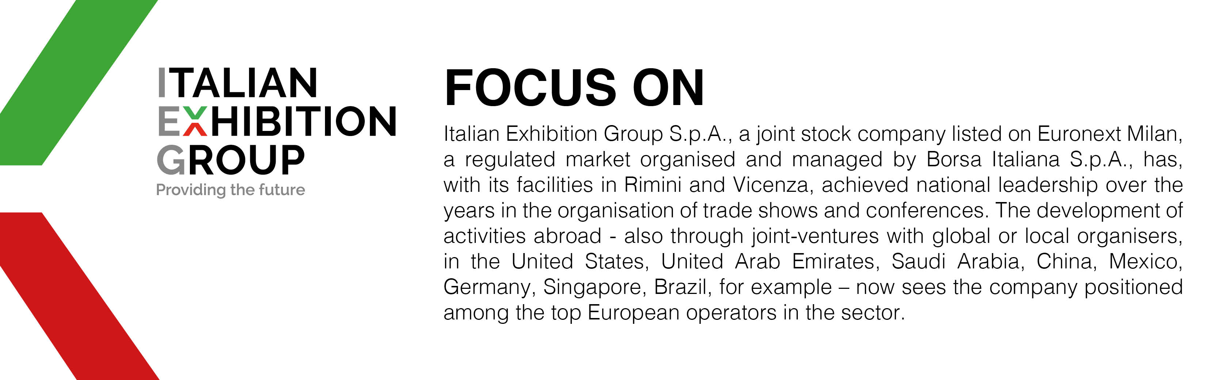

This press release contains forecast elements and estimates that reflect the management’s current opinions (“forward-looking statements”), particularly regarding future management performance, realization of investments, cash flow trends and the evolution of the financial structure. For their very nature, forward-looking statements have a component of risk and uncertainty, as they depend on the occurrence of future events. The effective results may differ (even significantly) from those announced, due to numerous factors, including, only by way of example: food service market and tourist flow trends in Italy, gold and jewellery market trends, green economy market trends; the evolution of raw material prices; general macroeconomic conditions; geopolitical factors and evolutions in the legislative framework. Moreover, the information contained in this release does not claim to be complete, and has not been verified by independent third parties. Forecasts, estimates and objectives contained herein are based on the information available to the Company as at the date of this release.

